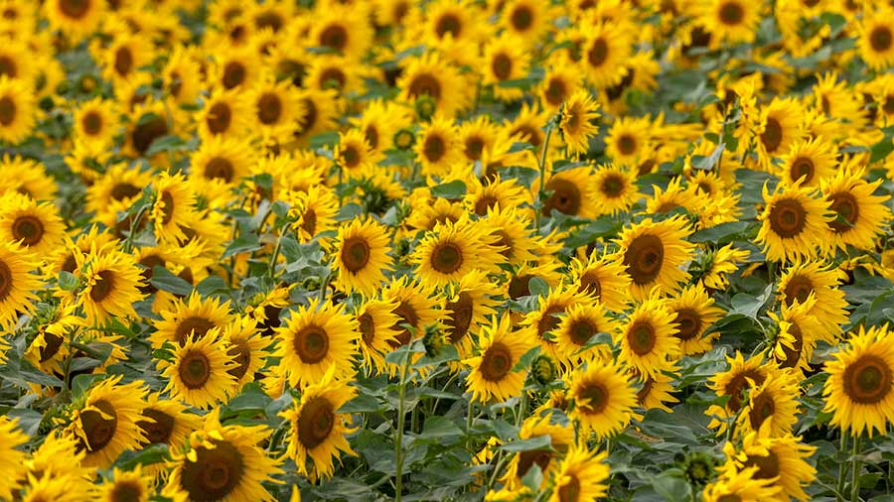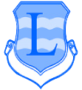

**Summer Term Year 2**

**Lingham Primary School**



**PE**

**Science**

**Maths**

**English**



* Multiplication and Division- counting in 2s, 5s and 10s, making and adding equal groups, grouping and sharing
* Fractions- a whole, a half, a quarter of a shape and of a quantity
* Place Value to 100
* Time- o’clock, half past, quarter past

Our key texts:

* The Secret of Black Rock
* My First Animal Encyclopedia
* Class Three all at Sea

Our writing genres:

* Journey narrative
* Non-chronological reports
* Defeating the monster narrative
* Games- Rugby Tots
* Athletics
* Animals
* Plants including trees and flowers

**DT**

**Art**

**Geography**

**History**



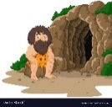

* Designing a chair for a bear
* Sculpture and 3D- paper play
* Local Area Coastal Study

Comparison between Moreton and New Brighton

* NESW, Positional Language
* The seaside- how has the seaside changed?
* New Brighton



**Summer Term Year 1**

**Lingham Primary School**

**RE**

**Music**



**Other bits & bobs**

* Judaism- Shabbat
* Judaism- Rosh Hashannah
* Fairy Tales: timbre and rhythmic patterns
* Superheroes: pitch and tempo

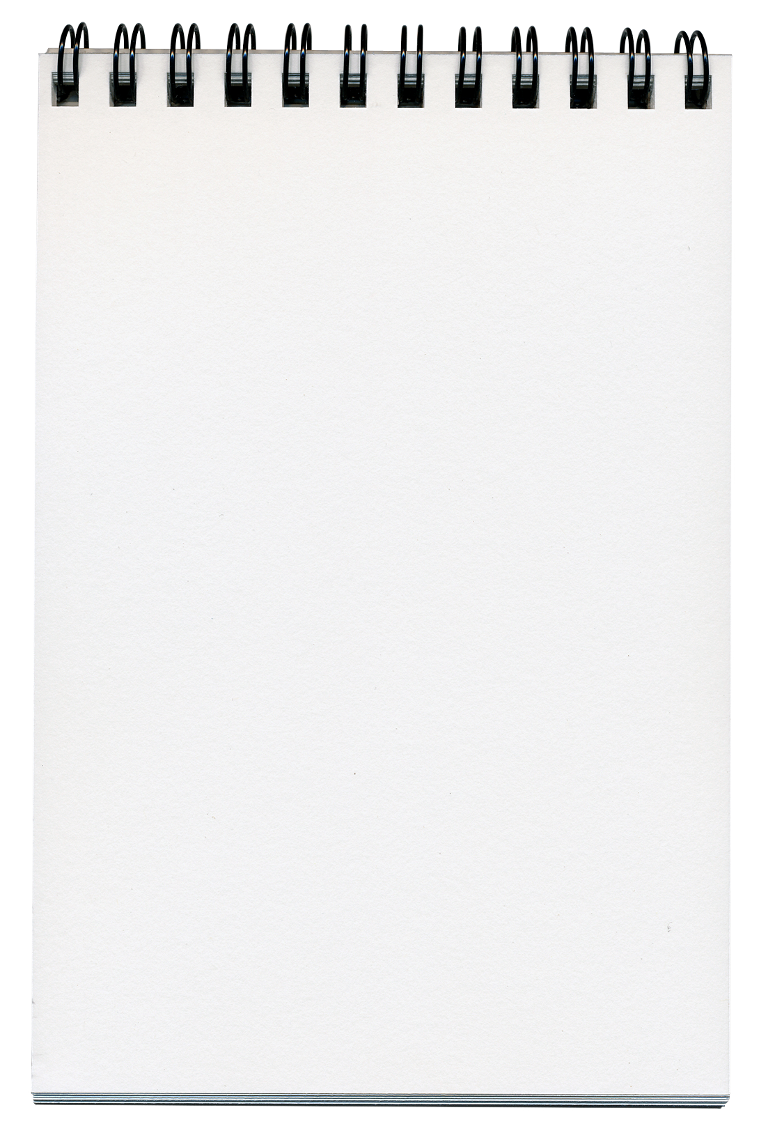

* Rugby Tots is every Thursday morning during Summer 1
* Please bring your reading books in every day.
* Reading books will be changed on Thursday and new ones given out on Friday
* Please continue to read at least 3 times a week- record this in your reading record.



**Computing**

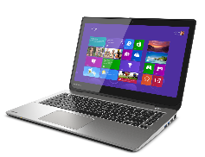

**PSHE**

* Safety included trusted adults and safety in the home
* Caring for other, similarities and differences
* Digital Imagery
* Programming- Beebot
* Online Safety

