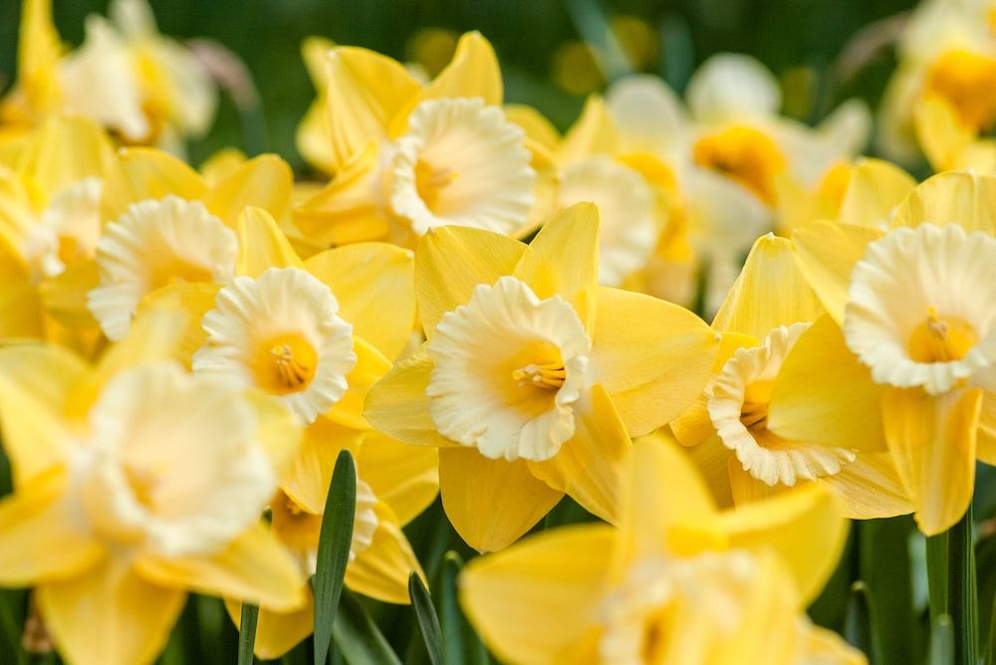

**Spring Term -F1**

**Lingham Primary School**



**PE**

**Communication and Langauge**

**Maths**

**English**



* Hold conversation when engaged in back-and-forth exchanges with their teacher and peers
* Begin to listen to and talk about non-fiction books, developing a familiarity with new knowledge and vocabulary
* Articulate ideas & thoughts in well-formed sentences
* Using new vocabulary and correct tenses

Use sequencing vocabulary – *first, next, after*

Use talk to help work out problems, organise thinking & activities explain how things work/why things happen

Our key texts:

* The Storm Whale in Winter by Benji Davies
* The Great Storm Whale by Benji Davies
* Hello Mr Whale by Sam Boughton
* Grandma Bird by Benji Davies
* Hello Penguin by National Geographical
* I can fly by Fifi Kuo
* And tango makes three Justin Richardson

Increase confidence in subitising by continuing to Explore patterns within 5

continue to develop verbal counting to 20 and beyond

*Length*

*Spatial vocabulary*

*More complex patterns – ABB, ABBC, ABC*

Explore symmetrical patterns, in which each side is a familiar pattern, linking this to ‘doubles’.

Become more familiar with the counting pattern *beyond 20.*

*Mass*

*representing spatial relationships as maps*

*Numerical Patterns – staircase patterns*

* Fundamental skills
* Dance

**The Natural World**

**People, Culture and Communities**

**Past and Present**

**PSHE**



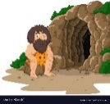

* Occupations:
* Global warming
* China
* Church (Easter celebration)
* Winter
* Ice – melting ice/freezing
* Solid/liquid
* Jungle animals
* Shadows
* Timeline – The Great Race (China)
* Who is in my family?
* Who helps me?
* Home and family school/ community

**Special Relationships**

Building Relationships- Playing cooperatively with others and taking to account their ideas

**Following Instructions**

Managing Self- Showing resilience and perseverance in the face of challenge



**Spring Term – F1**

**Lingham Primary School**

**Being Imaginative and Expressive**

**Creating with Materials**

**Other bits & bobs**





**Celebration**

African culture

Kwanzaa music

**Music and Movement**

Action songs

Finding the beat

* PE is every Friday
* **Please bring reading books into school daily**. Each child will have a book change day– written in reading log
* Please remember to bring a water bottle every day.
* Please bring appropriate cold/wet weather items – hat/scarf/gloves
* Please provide a pair of wellies to leave in school for outdoor play (lablelled with name)
* Please verify the observation app (EvidenceMe)

Using lines to represent objects and describing textures. (Animals)

Drawing- observational pictures of plants/flowers

**Henri Rousseau – creating animal scene**

**Van Gogh - sunflowers**

