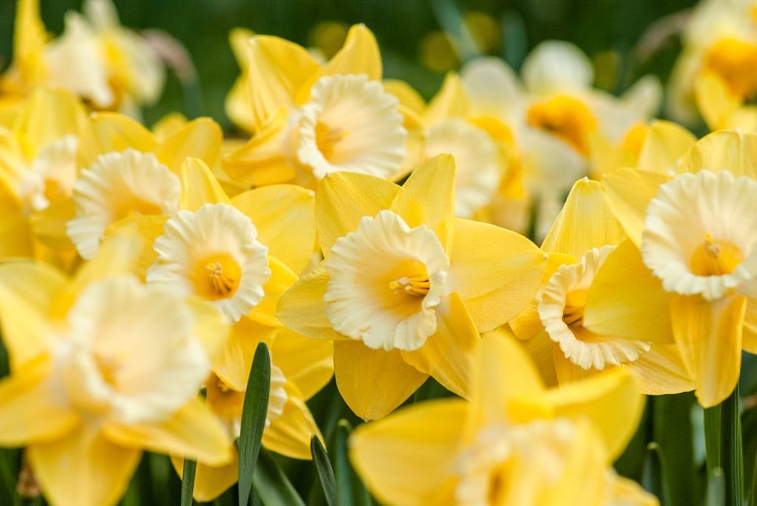

**Spring Term Year 2**

**Lingham Primary School**



**PE**

**Science**

**Maths**

**English**



* Count and compare amounts of money
* Multiply and divide by 2, 5 and 10
* Measure in centimetres and metres
* Order lengths and heights
* Measure in grams and kilograms

Our key texts:

* The Land of Bumbly Boo
* The Quangle Wangle’s Hat
* Edward Lear
* Grandad’s Island

Our writing genres:

* Nonsense poems
* Non-chronological report
* Setting description
* Return story
* Dance
* Fundamental skills
* Living things and their habitats
* Food chains
* Habitats around the world
* Rainforests
* Life in the ocean

**DT**

**Art**

**Geography**

**History**



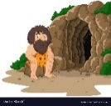

* Explore and evaluate a range of puppets
* Express likes and dislikes of the designs
* Design, make and evaluate a hand puppet.
* To develop knowledge of colour mixing.
* To know how texture can be created with paint.
* To use paint to explore texture and pattern.
* To evaluate and improve artwork.
* Identify the position of the equator, northern and southern hemisphere
* Locate countries near the equator on a world map
* Describe how the climate in Antarctica is different to the UK
* Know the 7 continents and 5 oceans
* Explore who Lord Leverhulme is and explain why he was successful.
* Visit Port Sunlight to learn more about the Lever-Brothers factory.
* Discuss how Lord Leverhulme changed the Wirral.



**Spring Term Year 2**

**Lingham Primary School**

**RE**

**Music**



**Other bits & bobs**

* How important is it for Jewish people to do what God asks them?
* How important is it to Christians that Jesus came back to life after the crucifixion?
* Orchestral instruments through traditional stories
* Listen to and analyse film music
* Write a play script and use appropriate music to accompany it



* PE is every Wednesday
* Please try your best to listen to your child read 3 times or more per week and sign the reading record
* There will be an opportunity for our year 2 children to showcase their work this term – letter to follow.
* Our year 2 trip this term will be to Port Sunlight in line with our History topic – a letter will follow.



**Computing**

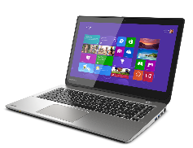

**PSHE**

* Communicating online
* Appropriate contact
* Rules beyond school
* My local community
* To understand and use algorithms to make predictions
* Understand how computers can help humans survive in space
* To interpret data

