SEND SNAPSHOT

PARENT/CARER EDITION 15
December 2023

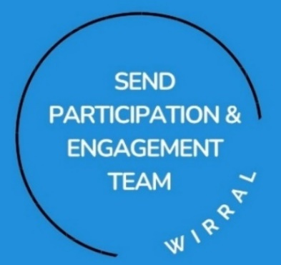
Hi Everyone,
Hope you’re all well and looking forward to Christmas. Whilst the children and young people (and their teachers) are excited to break up for the holidays, we know that for many of us Parents/Carers, the thought of trying to keep our children safe and happy can feel a little daunting.

When we’ve spoken with Parents and Carers it became clear that you might like a SEND CHRISTMAS SNAPSHOT to help you manage the festive period. With the help of our colleagues working in Health, we have put together some useful information and tips for the Christmas holidays, often a rather tricky time for our SEND young people and their families. We’ve also added a list of the services in Wirral along with their contact details.

It’s been lovely to meet up with so many of you at our regular SEND Parent and Carer drop in sessions. We’ve made our way around settings across the Borough and it’s been fab to be invited into so many schools and meet up with you. The SEND information sessions are open to all SEND Parents and Carers (not just those with children and young people attending that school)

The dates for the Parent & Carer SEND information sessions for 2024 will be advertised in the What’s On section of our new SENDLO website, social media, via schools & 3rd sector social media channels. Watch this space- https://www.sendlowirral.co.uk/
Twitter - @lowirral

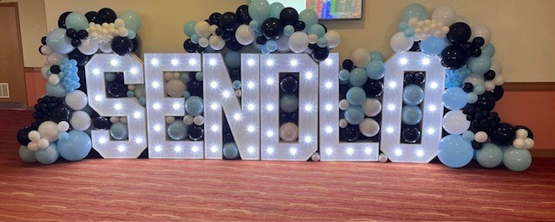
We were delighted to see so many of you at last month’s SENDLO LIVE event at the Floral Pavilion. Over 700 of you visited during the 1-8pm timeframe and your feedback was fantastic. We’re made up to hear that the 55 services in the SEND Marketplace, the Workshops and live demos of SENDLO helped you to get answers to your questions and leave better informed.

The Positivitree kindly arranged for Parents and Carers to support other Parents and Carers on the day and our SEND Youth Voice group were on hand to lend peer support to our younger visitors. We were treated to a rolling programme of expressive dance from Creative Youth Development who powerfully used their voice to raise awareness of the difficulties and barriers young people with SEND can face.

We would like to wish you a very Merry Christmas and a Happy New Year.

Sally and Poppy
The SEND Participation and Engagement Team

Contents | Page
Spotlight on the SEND Designated Clinical Officer | 4
Public Health information | 5
Christmas activities and tips | 8
Directory of services and contact details | 12
Additional resources | 20

Spotlight on Imogen Jones – Designated Clinical Officer for SEND
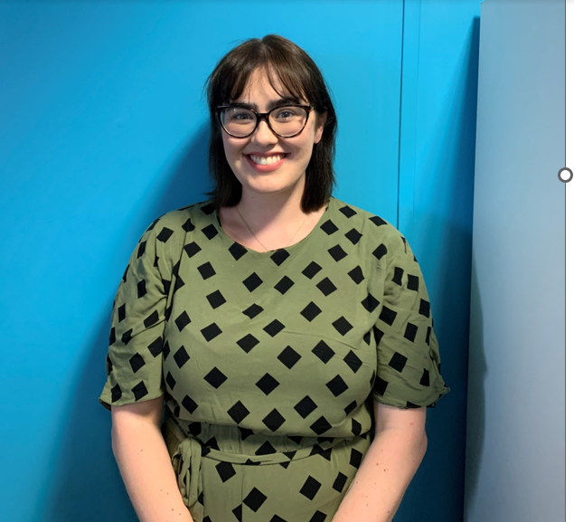
Hello, my name is Imogen Jones and I’m the new Designated Clinical for SEND in Wirral Place and I am part of a wider group of Designated Clinical Officers within Cheshire and Merseyside Integrated Care Board.

I am a registered Nurse by background, and I have worked with Children, Young People, and their Families since 2016, specialising in Safeguarding and Child Protection. I am very passionate about Children and Young People’s health and social outcomes, their opportunities and helping improve and change systems to support Children, Young people, and their Families. I enjoy working with communities and like to get out and about to meet people within their communities and safe spaces.

The Designated Clinical Officer Role for SEND is a varied and exciting role but can be broken down into three main areas: Oversight, Coordination and Strategic:

- Oversight – across all health professionals delivering healthcare to individual disabled children, young people and those with special educational needs. The DCO works in partnership and co-production to ensure the understanding of SEND; supporting with signposting to appropriate professionals/services; and networking with the wider system, including the voluntary sector.

- Coordination – supporting providers in relation to responsibilities and accountability relating to SEND, such as health information shared on the Local Offer, processes regarding the health element of Education, Health and Care plans (EHCP), complex case management, Early Notification of children with SEN/possible SEN to the LA, and many other groups such as Children & Young People’s Continuing Care and the transition of young people with SEND to adulthood.

- Strategic – contributing to the various SEND boards and groups, including SEND partnership, SEND joint commissioning and SEND health performance and compliance. The identification of gaps in provision are escalated to appropriate NHS Place.

I look forward to meeting and working with Children, Young People and Parent/Carers at ongoing engagement programmes to help improve outcomes for SEND in Wirral!

More information on the DCO Role –
Designated Medical Officer / Designated Clinical Officer resources (councilfordisabledchildren.org.uk)
Contact: Imogen Jones
Email: imogen.jones@cheshireandmerseyside.nhs.uk

Public Health – useful information for keeping well over the Christmas period
Simple things mean a lot.
Cold and damp weather, ice, snow, and high winds can all make us more vulnerable to winter illnesses and aggravate existing health problems.
These simple things can help protect you and others from cold weather and serious illnesses:

Regularly wash your hands and sanitise surfaces.
Washing your hands is one of the simplest ways to prevent yourself and others from catching illnesses like flu, norovirus, the common cold and more.
All you need is 20 seconds, warm water and some soap to wash your hands and prevent the spread of germs. If you don’t have any water or soap to hand, you could use an alcohol-based hand sanitiser with at least 60% alcohol instead. Remember that hand sanitiser is not effective for norovirus!

You should wash your hands as often as possible, and always when:
● Using the toilet or changing a nappy
● Preparing or handling food, and before and after eating
● After blowing your nose, sneezing or coughing
● After touching animals and pets or any of their belongings such as food bowls
● Before and after treating cuts or wounds
● Before and after visiting a healthcare setting or hospital
● After you touch surfaces that come into regular contact with others such as handrails and door handles, and spaces such as public bathrooms and communal kitchens

It's important to regularly sanitise surfaces to avoid them becoming contaminated with germs from you and others, especially if they are touched by someone who is ill.

Sanitising surfaces such as worktops, handles, light switches, electronic devices and work surfaces can help prevent the spread of winter illness.

Wear layers
Your body needs to keep around 37ºC or ‘core temperature’ to stay healthy. Keeping warm over the winter months can help to prevent serious health problems such as heart attacks, strokes, pneumonia and depression. There are many ways you can keep yourself warm, including:
- Wearing multiple thin layers of clothing
- Wearing a hat, scarf and gloves when you go outside
- Wearing bed socks and thermal clothing at night

Keep your home warm
Low indoor temperatures can also have a serious impact on people who have medical conditions.

To help keep your home warm:
- Keep bedroom windows closed at night
- Fit draught excluders around doors and windows
- Keep the most-used rooms to 18ºC if you can. If you are struggling with energy costs, visit www.wirral.gov.uk/costofliving for more information or call Ask us Wirral at 0808 2787848 .

While keeping windows and doors shut is important to keep your home warm, letting fresh air in can help prevent mould and damp. Mould and damp can aggravate respiratory problems, infections, allergies or asthma and can also affect the immune system.

Additionally, it can help remove air that contains virus particles and prevent the spread of respiratory infections such as flu, COVID-19 and colds. Good ventilation can help with better sleep and concentration, and fewer sick days off from work or school.

If you can, ventilate rooms when people are not in the house. This simple action helps to get some fresh air in prevent mould, damp and infections. You can find further information about mould and damp here. Private and social rented landlords should respond to damp and mould and take preventative action.

Find advice about ventilation to reduce the spread of infections here.

Check the weather
Temperatures can drop significantly during winter months. Keep an eye to the weather forecast and the news will help you to plan ahead and get prepared to face low temperatures.

Radio, TV, online weather checkers and mobile apps can be helpful way to keep informed. You can also register here to get the weather alerts.

If bad weather is forecast (below 5C), keep warm and check you’ve got enough medication and food in case it’s harder to leave the house. Check with your local pharmacy if they offer free delivery. Try calling Wirral Food Bank if you are struggling with food.

Get vaccinated.
Vaccines are the most effective way to prevent many infectious. Flu vaccinations are advisable for those with a medical condition that makes them more vulnerable, such as a heart condition. If you are aged 65 or over, pregnant, carer or have a health condition, you may be eligible to get free flu and covid vaccination. Check with your GP or local pharmacy. For further information visit NHS Seasonal vaccinations and winter health.

This year the following children will be eligible to be vaccinated for the flu:
- all children aged 2 and 3 years (provided they were aged 2 or 3 years on 31 August before flu vaccinations starts in the autumn)
- all children in primary school
- secondary school-aged children (Years 7 to 11)
- children aged 2 to 17 years with certain long-term health conditions

All parents/carers should have been contacted to complete your child’s e-consent form (https://www.wchc.nhs.uk/econsent/) by now. If your child missed their flu vaccine then the school immunisations service run clinics on a Tuesday and Thursday. You can contact them on 0151 514 2510 to book in.

Look after your child:
During the winter period, children and young people can be more vulnerable to common infections. These infections will be mild illness and can be treated at home in most cases.

It is important that parents and carers learn how to identify symptoms of minor infections, how to manage at home and what can be done if it gets worse. Download NHS Healthier Together App on your mobile phone, register your child and to find out clear and accurate information.

For further information, check https://www.simplethingswirral.co.uk/

Christmas activities and tips

Autism-friendly film screenings – The Light Cinema
There are a number of autism-friendly film screenings over the Christmas break at the Light cinema. Please click here for more information:
https://newbrighton.thelight.co.uk/autism-friendly

Jumpin’ Joseph’s Autism-friendly hour
There are a couple of autism-friendly hours at Jumpin’ Joseph’s over the Christmas period. Click here for more information:
https://jumpinjosephs.co.uk/activity/autism-friendly/?date=2023-12-30

The Positivitree
For activities for parent/carers over the Christmas period at the Positivitree, please click here:
https://www.sendlowirral.co.uk/news/the-positivitree-festive-sessions

The Hive
For Christmas opening times and activities at the Hive, please click here:
https://www.thehiveyouthzone.org/christmas-opening-hours/

Christmas tips
The Neurodevelopmental team have shared some helpful resources to help support our families and young people over the Christmas period.

Gifts and surprises
Sharing gifts can be exciting and fun for many people. For some of our neurodiverse young people, they may find this very overwhelming. Opening a gift can put a lot of pressure on the person who is receiving. It can lead to lots of worries thoughts such as “How am I supposed to react?” “What if I don’t like the gift?” Some preparation before the day is always helpful. Role play can give an opportunity for the individual to practice how they might respond.
Sometimes the thought of opening all the gifts and not knowing what they are getting can cause anxieties. It is ok to make any special alterations to how you celebrate Christmas to ensure your neurodiverse person feels comfortable. For some people, having pictures of what all the gifts are in advance help. Others like to show them the gift before they wrap them up. That way they can join in with the festivities without the extra worries.
The National Autistic Society have some great hints and tips to support families to prepare for Christmas. Follow the link below for more ideas.
Tips (autism.org.uk)
Sensory Needs
Christmas often comes with lots of sensory stimulation. Bright, flashing lights, new smells, crowded areas. This can be really hard for neurodiverse people. It is always a good idea to plan ahead to support there needs. Is there somewhere they are able to go to relax and reduce that sensory input? If you are going out, plan some quite time within the day to allow for some calming activities. The sensory intergration education website has a Christmas sensory survival toolkit that is available to download. See the link below.
Christmas Sensory Survival Kit (sensoryintegrationeducation.com)

Emotional Regulation
For young people who struggle with emotional regulation, festivities can sometimes lead to frustrations. This article written by Understood, talks about why this can sometimes happen and how to manage.
Tantrums over gifts: Why they happen and what to do (understood.org)

Other hints and tips
The autistic girls network shares some additional ideas about how to manage over Christmas and other large social events. Do not forget that girls’ traits are often missed. This can lead people to believe that they are coping better than they are.
An Autistic Friendly Christmas - Autistic Girls Network

Christmas can be hard.
Do not forget that Christmas is not a happy time for everyone. For those who are struggling, the following services are available for support:
CAMHS - Requesting help from CAMHS: Cheshire and Wirral Partnership NHS Foundation Trust (mymind.org.uk)
CAMHS crisis line- 0800 145 6485
Young minds -What to Do if You Find Christmas Difficult | Blog | YoungMinds
Kooth.com - Kooth provides free, safe and anonymous mental health and wellbeing service, providing online counselling and support for children and young people aged 10 to 25 Home - Kooth
Papyrus Papyrus UK Suicide Prevention | Prevention of Young Suicide (papyrus-uk.org)
Samaritans Samaritans | Every life lost to suicide is a tragedy | Here to listen
'Stay Alive’ app which has resources for those in a mental health crisis: https://www.stayalive.app/
Crisis support for children and young people in Cheshire and Wirral (mymind.org.uk)

Directory of services and contact details

Team/Service | Page
Adult Integrated Disability Service | 12
CAMHS | 13
Children with Disabilities Team | 13
Children’s Respiratory Service | 13
Children’s Speech and Language Therapy (SaLT) service | 14
Children’s Therapy services | 14
Continence (Children’s Service) | 14
Cystic Fibrosis | 15
Diabetes (Childrens) | 15
Dietetics – Children (Community) | 15
Dietetics - Children’s (Hospital) | 15
Epilepsy | 15
Family Matters | 15
Local Offer (SENDLO) | 16
0-19 Children's Neurodevelopmental Team | 17
Occupational Health & Physiotherapy service | 18
Paediatric Dietitian Service | 18
SEND Youth Matters | 18
Wirral SEND Partnership | 19

Adult Integrated Disability Service

The Adult Learning Disability Social Work Team in Cheshire and Wirral Partnership NHS Foundation Trust, has social workers supporting adults with learning disabilities, along with their families and carers.

We are also integrated with the Community LD Health Team, who we regularly work together with.

We are based at the Millennium Centre in Leasowe.
Contact: Jeremy Hunt Tel:0151 488 8091

CAMHS

The CAMHS service provides treatment and support to young people that are experiencing mental health difficulties.

0151 488 8156 or email cwpmhsconadvice@nhs.net
or for referral information go to Access Service – Cheshire & Wirral Partnership NHS Foundation Trust www.cwp.nhs.uk

24/7 Mental Health Crisis helpline- 08001456485 cwpmhsconadvice@nhs.net

CAMHS Contact: Debbie Harrop, Clinical Lead – CYP Learning Disability Services, LD CAMHS Wirral Team Email: cwp.telephonemessagesld@nhs.net

Children with Disabilities Team

Contact: Peter Stanley, Advanced Social Work Practitioner
e-mail: peter.stanley4@nhs.net

Children’s Respiratory Service
The Paediatric Respiratory Service at Arrowe Park Hospital looks after children with Allergies, Asthma, Cystic Fibrosis and Oxygen.
We’re a team of 4 Nurse Specialist that work alongside the Paediatric Consultants mainly in Outpatients and the Community, however, may see them if they are known as inpatients. We have started this year to pilot a new way of providing core training to schools, where they are invited to attend sessions at the Hospital - mainly on Allergy and Asthma, as well as Epilepsy and Diabetes if needed.

Contact: Lauren Knight
Children's Respiratory Nurse Specialist, Arrowe Park - Women and Children's
Mobile: 07920783381
Children’s Speech and Language Therapy (SaLT) service
The children’s speech and language therapy team continue to offer a broad range of support for children with speech, language, and communication needs.
The team offer a blended approach to appointments. Virtual appointments via telephone or video are offered along with face-to-face appointments if we believe that face-to-face is more appropriate for clinical reasons. There continues to be many benefits to virtual consultations and teachers/teaching assistants/parents/carers can join the call which enables them to contribute and learn from the session.
Our trust website continues to be updated with helpful videos and links for supporting children and young people with speech, language, and communication difficulties. Please look at https://www.wchc.nhs.uk/services/childrens-speech-language-therapy/

Contact: Team Leader: Kate Gallagher
Email: wchc.childrenssaltteam@nhs.net
Direct dial: 0151 514 2334

Children’s Therapy services
Jane Fieldhouse, Team Lead Early Years Children's Physiotherapy, AHP.
Contact: E mail: janefieldhouse@nhs.net

Continence (Children’s Service)
Contact: Janice Evans, Service Lead Integrated Childrens Division
Email: janice.evans2@nhs.net

Cystic Fibrosis
Contact: Janet Dods
Email: jdods@nhs.net

Diabetes (Childrens)
Contact: Jane Edmunds Paediatric Diabetes Specialist Nurse
Email: jane.edmunds2@nhs.net

Dietetics – Children (Community)
Contact: Denise King/Helen Stanton, Clinical Lead Children’s Dietitian Tel: 0151-514 2827/extension 3126.
Email wchc.childrensdietetics@nhs.net

Dietetics - Children’s (Hospital)
Team telephone: 0151 604 7491/0151 604 7790
Team email: wih-tr.PaediatricDietitians@nhs.net
Vicky James Professional Lead/Clinical Lead Allergy & Gastroenterology
Emma Quayle Clinical Lead Cystic Fibrosis & Neonatal
Rona Cookson Clinical Lead Diabetes
Contact: Vicky James, Paediatric Dietitian/Professional Lead

Epilepsy
Contact: Jayne Murphy and Jenny O’Brien,
Children’s Epilepsy Nurse Specialists
Email:jayne.murphy7@nhs.netand Jennifer O’Brienjennifer.obrien1@nhs.net
Direct line – 0151 604 7672 extension 2187

Family Matters
We are a service that support families with children aged 0-19 years.

Each individual families’ identified needs are supported by a keyworker who will work alongside the families. We have 3 amazing teams in our service, and they are:

Adolescent Response Team – who provides support for families with children and young people aged 11 -18 years.

Targeted Family Support Team – who provide support for families with children and young people aged 0-19 years.

Family Group Conference Team – who provide support to children, young people and their families.

A Family Group Conference consists of Private Family Time and they encourage children and young people to take part in the decisions that directly affect them. We continue to deliver online bitesize sessions for Parents and Carers covering topics such as choices and consequences, managing anger and keeping children safe in the digital age.

We also deliver “Who’s in charge ?” which is an 8 week programme for parents/ carers who feel threatened, hurt or intimidated by their child .The programme aims to :
•Provide a supportive environment to share experiences and ideas
•Reduce the guilt and shame that most parents feel
•Offer help and guidance to develop individual strategies for managing your own child behaviour
•Explore ways of increasing safety and well being
Please contact David Tilling for any further information on the programme davidtilling@wirral.gov.uk
We are excited to be moving to a more integrated way of working with CSC and moving into 2 localities areas to enable a more effective multi-disciplinary way of working to improve outcomes for our families by linking in more closely with services within the local communities.
Contact: Emma Meaney, Service Lead Family Matters
E mail: emmameaney@wirral.gov.uk

Local Offer (SENDLO)
SENDLO (Wirral’s SEND Local Offer) website (https://www.sendlowirral.co.uk/)
provides information on the services children, young people and their families can expect from a range of local agencies, including education, health and social care as well as information about other local support services. Knowing what is out there gives you more choice and therefore more control over what support is right for you and your child. The SEND Local Offer helps you find out what services are available in Wirral for children and young people aged 0-25 with special educational needs and disabilities.
Our new and improved SENDLO launched in September 2023. To develop the website, a project team has had input from SEND children and young people, parents, carers, third sector organisations, professionals in Early Years, Commissioning, Health, Education and Care.
The new web site has had really positive feedback and benefits from enhanced accessibility tools including:
•Audio text reading
•The use of Images i.e. Widget symbols, video.
•Background exchange (colour change)
•Translation availability
Contact: E mail: sendlo@wirral.gov.uk

0-19 Children's Neurodevelopmental Team
We are a small branch of the 0-19 school nurse service. We provide the assessments for school age children for ADHD/ASD and DCD. Parents and SENCO's can contact us for advice and guidance around assessments or general behaviours. The team is available Monday to Friday 9am-5pm via the 0-19 duty line on 0151 514 0219.
also offer a drop in service at their hubs -The hubs are a safe and confidential environment to discuss health related topics, including:
• healthy eating
• weight management
• bedwetting
• behavioural concerns
• emotional wellbeing
• confidence/self-esteem
• sexual health and lifestyle advice
- sleep behaviour
• signposting and referrals to other services if needed.

Weekly Hub drop-in clinics (no appointment needed):

Every Monday, 3.30pm – 5.30pm Every Tuesday, 4.00pm – 6.00pm
Eastham Clinic St. Catherine’s Health Centre
Eastham Rake Derby Rd
Eastham Birkenhead

Every Wednesday, 4.00pm – 5.30pm Every Thursday, 3.00pm – 5.00pm
Greasby Clinic Victoria Central Health Road
Greasby Road Clinic Room
Greasby Mill Lane
Wallasey

Every Thursday evening 5.00pm – 7.00pm
The HIVE
Wirral Youth Zone
Birkenhead

Contact: Beckie Banks
ADHD/ASD Nurse
07584856185
Please note my working hours are 9am - 5pm
Monday to Friday (Term Time)

Occupational Health & Physiotherapy service
Therapists are mainly based at Cherry Tree House, Clatterbridge 0151 514 2525 (Early Years Occupational Therapy (OT) and Physio, School age physio and Sensory-motor OT) and Millennium Centre (School age OT)
Contact: Tel: 0151 666 4790. Phone calls are welcomed for advice.

Paediatric Dietitian Service
Vicky James, Rona Cookson & Emma Quayle are the hospital Dietitians. We see children with Diabetes, Cystic Fibrosis, Allergy, Gastroenterology & faltering growth who are under a hospital consultant. Please contact us on if you have any queries.
Contact: Vicky James 0151 6047491
Paediatric Dietitian
Wirral University Teaching Hospital NHS Foundation Trust
0151 678 5111 extension 2914 or 0151 604 7491 Tues-Fri

SEND Youth Matters
The SEND Youth Voice Group are a group that run weekly at Pilgrim Street Arts Centre, Pilgrim Street, Birkenhead, CH41 5EH. It is aimed at SEND young people aged 13-25yrs.

It is free, fun and friendly.

The group work together to raise issues about SEND for young people in Wirral, delivering and working on ideas and plans to help better the lives of young people in Wirral. They also support in working with professionals in all fields and
Organisations. They also have the opportunity to train as peer educators and gain skills in facilitation, workshop leader, speaking in public, and varying ways to express and understand others.

Please feel free to call us to discuss any concerns or issues, we are happy to support. We also offer GIRLS and LADS projects which need to be referred into for those young people struggling and needing more support.
Email: shiraleacoldicott@wirral.gov.uk for more information on these projects.

Creative Youth Development run a range of different weekly groups and sessions. There’s something for everyone. Here’s just some of the activities on offer: Dance, Drama, Photography, Art, Anime, Technical Theatre, Rap and SEND Youth Voice Group

Contact: Seline Wakerley for more information on selinewakerley@wirral.gov.uk

Wirral SEND Partnership

Who we are and what we do
Wirral SEND Partnership (SEND IASS) provides free and confidential impartial legally based information, advice and support to disabled children and young people, and those with SEN, and their parents. Wirral SEND Partnership also covers other issues related to special educational needs/disability (SEND) such as health and social care issues.

Wirral SEND Partnership offers:

- Face-to-face meetings
- Contact by telephone, email or social media
- Support in meetings with other professionals
- Help with letter writing or form-filling
- Appointments at a place to suit you
- Information about other services

Who can use our services
Information is available in a range of languages and formats if needed and Information, advice and support can be about any issue related to special educational needs or disability. You can self-refer or can ask someone else to refer on your behalf. Young people (aged 16-25)​ can ask for support separately from their parents/carers if they wish. Click on the dedicated webpage for information about SEND for children aged 11-15 and young people aged 16-25.

The office is open Monday to Friday from 9.00 a.m. to 4.30 p.m. We recommend meetings are arranged by telephone appointment.

Wirral SEND Partnership also help parents to navigate Wirral’s ‘Local Offer’ of services. ​
How to access our services
Parents or young people can contact our services directly using the telephone number or email address below. Professionals can also contact Wirral SEND Partnership in the same way.
Contact: 0151 522 7990 (staffed Monday to Friday 9am – 4.30pm)
or email ias@wired.me.uk
Wirral SEND Partnership Service Manager – Michelle Jones

Additional resources

Other resources to support you are:
The Family Toolbox
The website which has loads of great information for family activities. https://familytoolbox.co.uk/family-life/holidays/
Facebook: Family Toolbox

The Positivitree
website https://thepositivitree.com/events/
Facebook: The Positivitree (parent-carer members group)

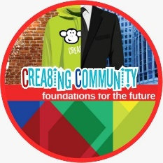
Crea8ing Community
Website: https://www.crea8ingcommunity.com/whats-on.html
Facebook: Crea8ing Community

Zillo
A fantastic website made by young people for young people.
Website: https://www.zillowirral.co.uk/

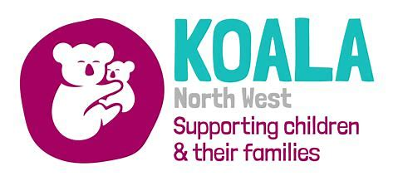
Koala North West
Website: https://koalanw.co.uk/
Facebook: Koala North West

SENDLO (SEND Local Offer)
Website: https://www.sendlowirral.co.uk/
Facebook: The Local Offer Wirral
Twitter: @lowirral

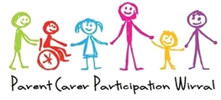
Wirral’s designated Parent Carer Forum (PCPW)
Website: https://wirralparentcarergroup.co.uk/
Facebook: https://business.facebook.com/ParentCarerParticipationWirral/

Who are PCPW?
PCPW are a group made up of parents and carers for children and young people aged 0-25 with Special Educational Needs and/or Disabilities who live on the Wirral. Their activities are funded by Department for Education and we are overseen by a National Charity-‘Contact a Family.’ They are the recognised “voice” by Contact A Family, and the Department for Education to participate with the Local Authority.
What do they do?
PCPW offer the Local Authority, commissioners and service providers the views and concerns of parent carers in order to influence service development, design and delivery on the Wirral. They aim to be the voice of parents and to contribute to the improvement of education, healthcare and social care services. PCPW hold events to gather your views and to provide you with information on SEND.
Are you a Parent or Carer?
- Are you a parent or Carer of Wirral children and young people with SEND aged 0-25?
- Do you have experience to share, need information and/ or want to be able to participate in project to provide feedback on services?
How to join PCPW?
To get a joining form or for more information please contact: Kate McCann (PCPW Administrator) by e mail at adminpcpw@wirralparentcarergroup.co.uk

